Note: This document is “view only”. Please create a copy of this document and save it to your drive.

**SOP- Team Member Offboarding- Systems Vault**

**PREREQUISITES**

[SOP MASTER - Team Member Onboarding & Offboarding- Systems Vault](https://docs.google.com/document/d/1HqV60Qly2Z54F19tthCtv7EV7rQrT-ziHlrEgWp2q3c/edit?usp=sharing)

[SOP- Password Sharing- Systems Vault](https://docs.google.com/document/d/1tEfj5QxLYcticR1H0C5vVt6V7qugElYMgfhypYgCucc/edit?usp=sharing)

[Teamwork PM](http://sarahnoked.com/teamwork)

[Zoom](https://us02web.zoom.us/account/user#/)

[Ontraport](http://sarahnoked.com/ontraport)

[Lastpass](https://lastpass.com/)

[Teamwork Chat](https://sarahnoked.teamwork.com/chat/channels/43094)

[Google Admin Console](http://admin.google.com/)

[Template- Offboarding Team Member- Systems Vault](https://docs.google.com/document/d/1SapBfiYQjxN_XF2AiqdK6xYoHI_dZzQjhjGPFn58npU/edit)

[Master: Team Member Details - Systems Vault](https://docs.google.com/spreadsheets/d/18Z8RMlT9UFzxmhKZOqucHuIaKXHb4hNYR_VU0e2RLxE/edit?usp=sharing)

**PURPOSE**

To ensure staff members are swiftly and properly removed from our files and our clients’ files/databases, etc. with a bon voyage!

**POLICY**

Staff Member Terminated setup should take place every time a team member is terminated or ends their contract with us or our client.

**PARTY**

Online Business Manager

**PROPERTY**

Online Business Manager

**PROCESS**

Part 1: Implement the “Staff Member Terminated” Task template in [Teamwork PM](https://sarahnoked.teamwork.com/)

Part 2: Send email notification [Template- Offboarding Team Member- Systems Vault](https://docs.google.com/document/d/1SapBfiYQjxN_XF2AiqdK6xYoHI_dZzQjhjGPFn58npU/edit) to Team Member (to their personal email and not @sarahnoked email)

Part 3: Update [Master: Team Member Details- Systems Vault](https://docs.google.com/spreadsheets/d/18Z8RMlT9UFzxmhKZOqucHuIaKXHb4hNYR_VU0e2RLxE/edit?usp=sharing)

Part 4: Remove user from [Ontraport](http://sarahnoked.com/ontraport)

Part 5: Revoke [Lastpass](https://lastpass.com/) access

Part 6: Downgrade user in [Teamwork PM](http://sarahnoked.com/teamwork)

Part 7: Revoke 1. SARAHNOKED.COM Google Drive Access/ Google Calendar access for contractors without @sarahnoked.com email address

Part 8: Delete/Reassign @sarahnoked.com email address

Part 9: Remove team member [Zoom](http://zoom.us) account

Part 10: Remove [Facebook](http://facebook.com) Admin Access

Part 11: Remove Lastpass Access

Part 12: If person was employee update documentation/notify accountant

**PROCEDURES**

**Part 1: Implement the “Staff Member Terminated” Task template in** [**Teamwork PM**](http://sarahnoked.com/teamwork)

1. From the SN Teamwork dashboard, click “Projects” in the top menu and navigate to the SN Day to Day Project
2. Click “Add New Task List” > Advanced > select the “Staff Member Terminated” task template
   1. Name the task list the ‘Staff Member Terminated: Staff Member’s name’ and click ‘Add this task list’
   2. Edit the privacy settings so it is seen only by you and Sarah
   3. Assign tasks and dues dates for all tasks.
3. The next steps of this SOP are laid out as tasks within your newly created task list.

**Part 2: Send email notification Template- Offboarding Team Member- Systems Vault to Team Member (to their personal email and not @sarahnoked email)**

1. Compose the following email [Template- Offboarding Team Member- Systems Vault](https://docs.google.com/document/d/1SapBfiYQjxN_XF2AiqdK6xYoHI_dZzQjhjGPFn58npU/edit) to the Team Members personal email address. This information can be found here: [Master: Team Member Details- Systems Vault](https://docs.google.com/spreadsheets/d/18Z8RMlT9UFzxmhKZOqucHuIaKXHb4hNYR_VU0e2RLxE/edit?usp=sharing)

**Part 3: Update** [Master: Team Member Details- Systems Vault](https://docs.google.com/spreadsheets/d/18Z8RMlT9UFzxmhKZOqucHuIaKXHb4hNYR_VU0e2RLxE/edit?usp=sharing)

1. Update termination date here: [Master: Team Member Details- Systems Vault](https://docs.google.com/spreadsheets/d/18Z8RMlT9UFzxmhKZOqucHuIaKXHb4hNYR_VU0e2RLxE/edit?usp=sharing)

**Part 4: Remove user from** [**Ontraport**](http://sarahnoked.com/ontraport)

1. Access [**Ontraport**](http://sarahnoked.com/ontraport) > Contacts
2. Find Contact and delete

**Part 5: Revoke** [**Lastpass**](https://lastpass.com/) **access**

See: [SOP- Password Sharing- Systems Vault](https://docs.google.com/document/d/1tEfj5QxLYcticR1H0C5vVt6V7qugElYMgfhypYgCucc/edit?usp=sharing)

**Part 6: Downgrade user in** [**Teamwork PM**](http://sarahnoked.com/teamwork)

1. Access Teamwork > 
2. Locate the team member that you are offboarding and click on their name to access their User
3. Click on the three dots on the top right hand side of their profile 
4. Reassign their tasks
   1. Click “Reassign User Items”
   2. Choose Sarah Noked to be the User to receive All Tasks 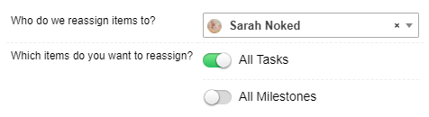
   3. Click 
   4. Set yourself/Sarah a task in Teamwork PM to re-organize the tasks
5. Downgrade the team member to a contact
   1. You should still be in the contacts profile
   2. Again, Click on the three dots on the top right hand side of their profile 
   3. Click “Downgrade to a Contact”

**Part 7: Revoke 1. SARAHNOKED.COM Google Drive Access/ Google Calendar access for contractors without @sarahnoked.com email address**

1. Remove Team member without @sarahnoked email address from Google Drive
   1. Access from all relevant google drive folders & docs by right clicking on the file or folder > Navigate to ‘Share’ > ‘Advanced’ > Click on the ‘x’ to remove access.
2. Remove Team member without @sarahnoked from Google Calendars
   1. Access Google Calendar
   2. Find the following calendars on the left hand side of the screen:
      1. SN Team Calendar
      2. Sarah Noked
      3. Sarah Noked Promotional
      4. Any specific Sarah Noked launch calendars
      5. Any client calendars that the team member might have access to
   3. For each one, hover over it and three dots will appear, 
   4. Click on the three dots > 
   5. Scroll down to 
   6. Find the team member that you are offboarding and click the  next to their name to remove access from the calendar
   7. Repeat for all relevant calendars

**Part 8: Delete/Reassign @sarahnoked.com email address**

1. Login to the [sarah@sarahnoked.com](mailto:sarah@sarahnoked.com) gmail account, open a new tab, and navigate to [admin.google.com/](https://admin.google.com/)
2. Select “Users”
3. Find the team member that you want to remove. Click on the three dots to the right of their name and click Delete 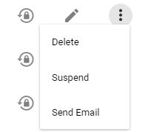
4. A User Deletion box will pop up, check off all options to transfer files 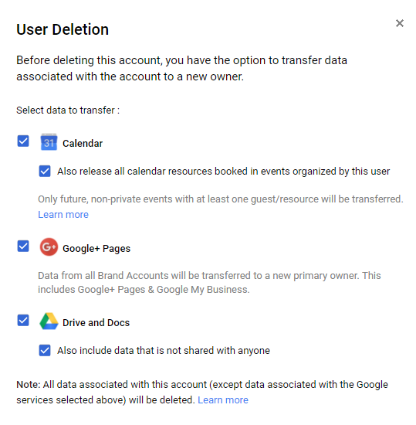
5. Click on 
   1. Transfer all files to sarah@sarahnoked.com
6. Click on 
7. Once you receive notification that the files have all been transferred, organize them

**Part 9: Remove team member** [**Zoom**](http://zoom.us) **account**

1. Log-in to Sarah’s master business [Zoom](https://zoom.us/) account > Users
2. Locate the team member you are offboarding and click on next to their account
   1. Click ‘Deactivate Account’

**Part 10: Remove** [**Facebook**](http://facebook.com) **Admin Access**

1. Access [Facebook](http://facebook.com) as Sarah Noked
2. Access all groups and pages as seen in the SN Master: URLS (master links) file
3. Revoke their access as Admin from pages
   1. Access the page
   2. Click > 
   3. Locate the team member you are offboarding and click 
      1. Click 
4. Revoke their access as Admin from groups if it is a free group
   1. Access the group
   2. Access it’s 
   3. Locate the team member you are offboarding under and click the three dots next to their name 
      1. Click 

Remove them from the Groups if it is a paid group

* 1. Access the group
  2. Access it’s 
  3. Locate the team member you are offboarding and click the three dots next to their name 
     1. Click 

**Part 11: Remove Lastpass Access**

See: [SOP- Password Sharing- Systems Vault](https://docs.google.com/document/d/1tEfj5QxLYcticR1H0C5vVt6V7qugElYMgfhypYgCucc/edit?usp=sharing)

**Part 12: If person was employee update documentation/notify accountant**

1. Make sure Sarah has a task to contact her accountant to properly offboard the team member

**Created by:**

**Department:** Growth

**Date:**

**Revised:**

**Revised by:**